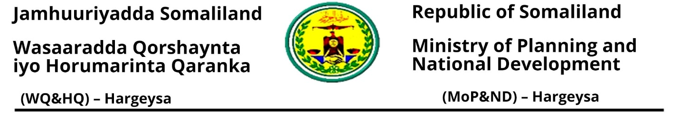

Shuruudaha Ururka Cusub (Local NGO) looga Baahan yahay.
- In laguu Hubiyo Magaca Ururka la diwaan gelinayo.
- 5 qof ama ka badan oo ah tiro kala dhiman ee Board-ka Ururka waa in laga helaa;
- Kaadhka Dhalashada
- Taariikh Nololeed(CV)
- Warqadda danbi La’aanta (C.I.D)
- Sawirada Board-ka (Photos)
- Dastuurka Ururka
- Warqadda Ansixinta Dastuurka
- Saxeexa Garyaqaanka
- Shambadda Garyaqaanka dhamaan Pages-ka
- Saxeexa Board-ka ururka
- Warqad Codsi ah oo ku socota wasaaradda Qorshaynta
- Astaanta Ururka oo sawir ah (Hard Copy)
- Warqadda Hantida Ururka (Office Asset)
- Registration form (A1) kala deg https://mopnd.govsomaliland.org
- Annual Plan Form (D2) kala deg https://mopnd.govsomaliland.org
- Dhamaan Document-ku waa in uu noqda asal (Original)
- Dhamaan Document-ka copy ka soo sameysta
- Cashuurta Ururka oo dhan 1,000,000 slsh

Xafiiska Qaybta Diwaangelinta
Wixi faahfaahin dheeraad ah fadlan nagala soo xidhiidh
Taleefannada kala ah: 063-4420502, 063-4424903 ama 063-3296176

