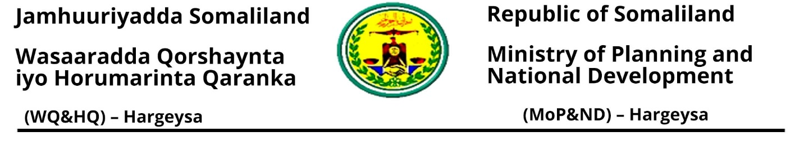
 | Requirements for New INGOs
1 | Request letter for registration
2 | A certificate of registration from country of origin and a proof of own operating office in country of origin.
3 | Detail information about the organization including a copy of its constitution and its profile (vision, structure, head office and geographical reach)
4 | Evidence of similar work carried out in the country of origin or in other countries (Reports, certificates of registration, LOA etc.)
5 | CVs of current Board of Directors, their passport-sized photos.
6 | The CVs of your international staff, certificate of no criminal conviction/Declaration of innocence form(Ministry) from their respective countries and justification as to why they are needed.
7 | Project Log form
 | New registration form (B1)
8 | Staff Form
9 | Submitting project Proposal for the new project that the new INGO will implement
10 | An evidence of an own office with a decision making authority in the country
11 | A receipt or proof of payment of the registration fee (from Ministry of Finance Development) 1500 USD

Registration Office
For more information, please contact us via email or phone numbers
Email: Doc.mopnd@gmail.com
Hashim Abdisamed: 063-4082994
Abdirahman Ismail: 063-4339623

