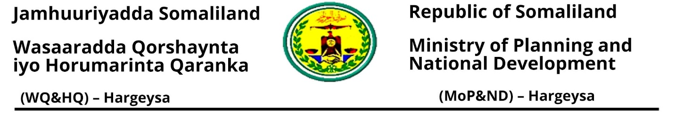
 | Requirement for Renewal INGOs
1 | Request letter for renewal registration
2 | Recommendation letter/s from line Ministry/ies
3 | Tax clearance letter
4 | Bank statements
6 | Annual reports C1
7 | Organizational details (B2 form) if information changed from the previous year.
8 | Asset registration form
9 | Staff list form
10 | Disbursement form
11 | Project log form
12 | If there are new projects please bring project documents/proposal donor agreement, project log frame, annual plan, and budget breakdown
13 | A receipt or proof of payment of the registration fee (from the Ministry of Finance Development) of 750 USD

Registration Office
For more information, please contact us via email or phone numbers
Email: Doc.mopnd@gmail.com
Hashim Abdisamed: 063-4082994
Abdirahman Ismail: 063-4339623

